*RAM-IT: ITRO’s Customer Support Web Portal*

Project Documentation Submitted to the Faculty of the

School of Computing and Information Technologies

Asia Pacific College

In Partial Fulfillment of the Requirements for

Introduction to Systems and Design for IT

MNTSDEV

By

|  |  |
| --- | --- |
| Aloya, Jayson | Langcauon, John Christopher |
| Prion, Jan Gabriel | Sajul, Marc Julian |
| Zamora, Marc |  |

Table of Contents

List of Figures iii

List of Tables iv

I. Introduction 1

1.1 Project Context 1

1.2 Statement of the Problem 1

1.3 Objectives 1

1.4 Significance of the Project 2

1.5 Scope and Limitations 2

II. Review of Related Literature / Systems 3

III. Current System 4

3.1 Technical Background 4

3.2 List of Processes 4

3.3 SWOT Analysis 4

II. Proposed Solution 4

4.1 Technical Background 4

4.2 Feasibility 5

4.2.1 Operational Feasibility 5

4.2.2 Economic Feasibility 5

4.2.3 Technical Feasibility 5

4.2.4 Schedule Feasibility 5

4.3 Requirements Analysis 5

4.3.1 Product Vision 5

4.3.2 User Classes and Characteristics 5

4.3.3 Product Backlog 6

4.3.4 Prototype 6

4.3.5 Product Roadmap 6

4.3.6 Release Plan 7

V. Conclusion 8

VI. References 9

VII. Appendices 10

Appendix A: Minutes of the Meetings 10

# List of Figures

Figure 1 Client Mode Wireframe 17

Figure 2 Server Mode Wireframe 17

Figure 3 Server & Client Mode - Home Page 18

Figure 4 Server & Client Mode - Login Page 18

Figure 5 Client Mode - Logged In Home Page 19

Figure 6 Client Mode – Contact ITRO 19

Figure 7 Client Mode - Chat System 20

Figure 8 Client Mode – Contact ITRO w/ Progress 20

Figure 9 Client Mode – List of FAQ Articles 21

Figure 10 ITRO – FAQ Article 21

Figure 11 Client Mode – Resources 22

Figure 12 Server Mode - Logged In Home Page 22

Figure 13 Server Mode - Notifications 23

Figure 14 Server Mode - Chat System 23

Figure 15 Server Mode – List of FAQs Article 24

Figure 16 Server Mode – FAQ Article 24

Figure 17 Server Mode – Add FAQ 25

Figure 18 Server Mode – Resources 25

Figure 21 Minutes of the Meeting – 05/05/2022 33

Figure 22 Minutes of the Meeting – 05/25/2022 36

Figure 23 Minutes of the Meeting – 06/01/2022 38

Figure 24 Minutes of the Meeting – 06/03/2022 40

Figure 25 Minutes of the Meeting – 05/10/2022 42

Figure 26 Minutes of the Meeting – 05/17/2022 44

Figure 27 Minutes of the Meeting – 05/24/2022 47

Figure 28 Minutes of the Meeting – 05/31/2022 49

Figure 29 Minutes of the Meeting – 06/02/2022 51

Figure 30 Minutes of the Meeting – 05/12/2022 53

Figure 31 Minutes of the Meeting – 05/19/2022 55

Figure 32 Minutes of the Meeting – 05/30/2022 57

Figure 33 Minutes of the Meeting – 04/14/2022 59

Figure 34 Minutes of the Meeting – 05/14/2022 61

Figure 35 Minutes of the Meeting – 05/16/2022 63

Figure 36 Minutes of the Meeting – 05/17/2022 65

Figure 37 Minutes of the Meeting – 05/18/2022 67

Figure 38 Minutes of the Meeting – 05/19/2022 69

Figure 39 Minutes of the Meeting – 05/21/2022 71

# List of Tables

Table 1 List of Processes 9

Table 2 User Classes and Characteristics 14

Table 3 Product Backlog 16

Table 4 Product Roadmap 26

Table 5 Release Plan 28

Table 6 Roles & Responsibilities 73

# Introduction

## Project Context

Asia Pacific College (APC) has an office that provides computers, IT laboratories, networks, a multimedia studio, and internet access to members of the APC academic community to enhance the quality and the learning opportunities of students of APC. The office of Information Technology Resource (ITRO) manages all the IT Sources within APC.

The ITRO lacks an online service that caters specifically to the students’ inquiries, concerns, and complaints. The three most well-known portal/website APC is the APC official website, the OTE portal, and the Students portal. The APC Official website is catering outsiders since the official website of APC is based on marketing. The OTE portal is for students’ evaluation of their instructors. Although the Student portal caters to the students, it is mostly for viewing personal information such as class schedules, grades, clearances, and grades.

Outlook is the main source where APC sends its updates and news. It is also the place where students can contact the schools and offices when they have inquiries or concerns. Since Outlook’s only filtering system is the subject, there is no other option for the administrators to organize different inquiries, concerns, or complaints which makes it more overwhelming to address each one. For the students, this feels like their inquiries, concerns, or complaints are not being heard, acknowledge, or addressed as soon as possible.

Microsoft Teams is an application that helps students and teachers make classes or groups for specific subjects. It has features that are helpful for students and teachers like posting files, updates, videos, images, and links, and it can have 3rd party tabs that support Microsoft teams. Although the platform is for students and teachers, it is not a platform to post news or updates unless it is relevant to the subject, the teacher endorses it, or it is important enough to make them post it on the platform.

The pandemic makes it extremely hard and tedious to get the word out there and using traditional means will be inconvenient like writing it on a whiteboard, posting it to the local bulletin board of the school, or just saying it to the whole crowd. The pandemic makes it so that people will have less physical contact with one another. thus, posting and using email to notify a large group is the best way to go.

RAM-IT is an informative web-portal that aims to assist ITRO in providing information regarding tech-based concerns from APC students and staff. This is achieved by creating an article collection page that contains How-To tutorials regarding common ITRO questions, a FAQ (Frequently-Asked-Questions) pages for common questions and concerns, a direct-messaging system where students can ask the ITRO directly if their concern isn’t solved by the articles and FAQ, while also having a status function where ITRO can track if the inquiry is solved or not, and a resource-tracking page where ITRO can display the status and availability of the office’s resources. Addition to these functions, ITRO can monitor the accounts that are accessing the web portal for security and moderating purposes.

The team proposes RAM-IT as it can solve the ITRO’s problem of needing a system that caters online service to APC students and staff in terms of answering their questions, concerns, and complaints, with ease and less-delay. With RAM-IT’s features like the article page containing How-To tutorials, an FAQ page regarding common questions and concerns that are addressed by the ITRO, a direct-messaging system if questions/concern is still not answered by the previous features, and a resource-tracking page where ITRO can display their resources, along with their respective status and availability.

## Statement of the Problem

APC is in need of a system that enables ITRO to efficiently provide support, services, and deliver information to the APC Community.

1.) ITRO personnel are unable to monitor if inquiries, concerns, and issues are already addressed.

2.) ITRO receives multiple inquiries of similar problem.

3.) ITRO does not have a system that provides information on available resources.

4.) ITRO is unable to monitor available resources.

## Objectives

To develop a system that enables ITRO to efficiently provide support, services, and deliver information to the APC Community.

1.) To develop a system that will serve customer support for ITRO.

2.) To reduce inquiries with similar problems received by the ITRO, by providing a system with an algorithm that answers inquiries.

3.) To provide a monitoring system that identifies available numbers of resources that can be borrowed.

## Significance of the Project

1. ITRO – they will benefit since they will have a specific place to address students’ inquiries.

2. APC Students – they will benefit since they will have a better place to gather information for their inquiries and if they still are confused, they have a better way inquiring.

3. APC Teachers/Instructors – they will benefit by being able to properly redirect students to the web portal if they are having difficulties related to APC. They will also be able to properly relay information for troubleshooting such as creation of linked in learning accounts.

4. APC Schools & Offices – they will benefit by knowing the specs or hardware that are available for them to use without moving out of their office go to ITRO and ask them personally or call them. They will also know what available computers are ready for them if they try to arrange a seminar that involves computers or applications that needs computer platform

## Scope and Limitations

1. The project only is available for those with the apc.edu.ph account.

2. The proponents will cover the development and training for the administrators and schools/offices head to be able to use our web portal.

2.A. The proponents will be handling the software, while ITRO will be handling the hardware.

2.B. The proponents will be handling the production of the web portal while the schools/office head will be providing the contents.

2.C. The ITRO will be the ones to seek out human resources

3. The project is for the ITRO in APC.

# Review of Related Literature / Systems

**1. Online student support systems in school**

Schools use media to illustrate a point or entertain the students that would consume the news and updates. Injecting the students with valuable information to inform them, the way they inject this information is not forceful enough to make students overwhelming or makes the discussion easier to digest rather than using a way of that would overwhelm the student. During a difficult year, an elementary school newscast brings kids together and gives them news and updates that is digestible and fun. The school does this because it is fun for the student who are presenting the news, and it is promoting positive morale [1]. Schools assigns classroom activities so that each student is participating in maintaining the community, there are possible two ways to help kids feel like they belong and keep them going throughout the day. Instructors can also attempt to set lofty standards for all students and provide enough support, delivering the message that they are capable. This is especially crucial for kids who have previously received conflicting or discouraging messages about their abilities from adults or themselves especially during the days of isolation of the pandemic, whether because of explicit or implicit biases [2]. The Department of Education wants applications to be submitted to the SSC, which will also verify their accuracy, legitimacy, and sincerity. To the extent that it is practical, the SSC will arrange for applicants' documents to be submitted online to reduce crowding at the actual offices. The SSC may obtain hard copies of application materials only when online submission is impractical, one of the provided rules need to be followed is; through the publication of process flow charts in prominent locations, social media, and other online portals, detailed instructions on how to submit application documents are widely distributed [3].

**2. Web portals**

A portal is a protected design. It is a multi-purpose website application that caters to the needs of its users. A portal is designed to provide visitors with a variety of resources and services. E-mail, discussion forums, knowledge bases, search engines, external links, online commerce, and forms are just few examples. There are far too many advantages to having a portal for students [4].

**2.A. Advantages of Web portals for educational use**

The goal of a student portal is to make the adjustment as simple as feasible, the portal needs to give a student a tool to assist them to find the information they need quickly. That is why students require a Digital Experience Portal – or a Student Portal. Instead of using multiple systems to search for information making a portal would make it easier for students to access, engage, and search for information. A student portal can make a platform that has a centralized data that is secure for people who has access to the portal [5]. The capacity to access all this information with a single sign-on is a major benefit of a student portal at the institutional level, while having the concept of a single point of access to crucial academic information sounds very ideal [6].

**2.B. Examples of web portals for educational use**

Ivy Tech Community College devised a method for finding students who have not yet registered for the upcoming semester and sending them a tailored notification that includes their name and a URL that is specific to them, thereby diverting them to class registration [7]

**3. Online Instruction Guides**

Distance learning is needed to train where the student and instructor are in separate locations for the guidance and resources on a given topic. In addition to giving lessons and scheduling check-in times with the teacher, this may entail communicating via computer and communications technology. Instructional television, video, telecourses, and other forms of instruction that rely on computer or communications technology can all be considered as forms of distance learning. These include video or audio instruction where the main means of communication between the student and the instructor is online interaction. It might also entail using printed materials that contain tasks that are the focus of written or verbal evaluations. Teachers, students, and parents who are transitioning or have already transitioned can find advice and information on online guides [8].

**3.A. How-to articles**

When presenting instructions to the students, the instructor should posit the queries and try to respond. The instructors’ instructions will be more effective if the questions are simple to answer. The questions should follow three golden rules which are Destination, what will be available to the audiences once it is complied with the rules to see, hear, and experience? Procedure, what are the precise steps that should need to follow to get from point A to point B? What equipment and materials should it require? What unique details should it need to follow the instructions? Time: How long does it need to accomplish the instructions? When training students, keep in mind the three golden rules [9].

**3.B. Frequently Asked Questions (FAQs)**

Frequently Asked Questions (FAQs) are necessary because it is effective for preventing similar inquiries to appear in the future. In addition, it will answer the questions that students have not thought of it in the first place. First thing they knew they will look for the answer of their problem and the second thing they knew they have found an answer to the problem that they did not know they need [10].

**4. Notification System**

A notification system is a set of protocols and procedures that can involve both human and computer components. The purpose of these systems is to generate and send timely messages to a person or a group. Its basic purpose is to alert a person that a particular event has occurred. There are many types of notification systems, an example of a simple notification system is when a user sets up a website to send them either e-mail notifications or desktop notifications when an update or an event occurs [11].

**4.A. Web Push Notifications**

Web Push Notifications are notifications that are sent to a user via desktop web or and mobile web. These are alert style messages that slide in a corner of the desktop screen and appear identical to push notifications delivered from applications in mobile. These notifications also appear whenever, as long as the browser of the user is open regardless of the particular website of the notification is open or not [12]. These notifications give advantages like: Sending messages to inactive users, Easy opt-in experience, increased engagement, swift delivery, and higher conversion rates [13].

**4.B. SMS Notifications**

An SMS notification is a short text message that is used to inform people about news, updates, emergencies, etc., that are relevant at the given time. The advantages of using SMS notifications are that it shortens the distance between people, it has higher rates than e-mails, for faster sharing of information, and to have a better reach (since not all people with smartphones have access to the internet 24/7.) These notifications can also market and bring more people to use your website even more [14].

**5. Search Algorithm**

Search algorithm uses unique formula to retrieve a specific information stored with a website data structure. The use of search operation to look for a specific keyword stored within the website. Based in the type of search operation, algorithm is classified into two categories [15].

**5.A. Linear search algorithm**

The most basic of all search algorithms as they require minimal amount of code to implement. Also known as sequential search it is best used for short list that are unordered and unsorted. It starts from the leftmost element then compare it one by one with each element to. Every item is checked and if a match is found then that item is returned, otherwise the search continues till the end of the data collection [16].

**5.B. Binary search algorithm**

The more convenient type of search algorithm when a list has a complex and large data structure. It solves the time complexity of a linear search. It starts from the middle element of the whole array of data as a search key. If the value of the search key is less than the item in the middle, it narrows the interval to the lower half. If the value is more that it searches the upper half. It then repeatedly checks from the second point until the value is found or the interval is empty [17].

**6. Synthesis**

Schools provide an informative portal in response of the pandemic; everything needs to be suited for the needs of the pandemic thus an informative web portal that supports the students in terms of their questions about certain procedures, topics, problem, etc. is a must in the times of the pandemic. Schools should provide their students support so that the students do not feel that they are being abandoned by the school and its facilities especially to those who are not comfortable in the online environment. The school shows this by making informative instructions to further their communication with the procedures of specific thing or a problem. Portals are efficient way to give information without any outside interference. Schools provide a place for students to learn and haven for students who wants a place that has no interruptions from the outside confinement of the school and because of the pandemic those are now non-existent. The problem arises of telling students on how a certain problem is solved and what are the procedures of it, and it can all be answered by making an informative web portal that supports, instruct, and notify the students about a problem that is relevant or common. Along with web portals, the use of a notification system can create faster sharing of information among user and administrators, as well as it can achieve a higher reach since notifications like SMS notifications can reach to users regardless of them being connected to the internet. Not only will a notification system will increase effectiveness of a web portal, but it will also give more engagement and higher rates of people visiting respective web portal.

# Current System

## Technical Background

This section describes the current systems that are being used the ITRO which consists of the official Asia Pacific College Website, Microsoft’s Teams, and Outlook.

The Asia Pacific College Website consists all of the information that outsiders need to know about Asia Pacific College, it contains the school’s history, its industry partners, its board of directors, its administrators, and its community of school heads, teachers, and students. The website also shows the offers that the school gives, whether it be courses for students to learn or the facilities that they ran in order to service them and the staff of APC. The website also directs them to the main source of recent APC news which is RAMpage the official APC newspaper. The website also has its different features like RAMI for inquiries of website users, Ram connect for online enrollment, and many more. The website has a contact us tab where people will be directed to a list of the schools and offices, the staff and their roles in their respective office, as well as their e-mail for people to contact if they have an inquiry.

Microsoft Teams is the school’s main application for applying online learning to their students. It is where professors are given the capability to create an online space (in this case a Teams group) in which they can collaborate with their students in an online setting, whether it be assigning homework, integrating their class notebook (OneNote), seeing each other online through scheduled meetings, and many more. Teams can also be used by organizations and students as well in order to create their own online spaces, whether it be for themselves, for a group, or for a whole community. For the students, teams can be used for directly messaging the ITRO personnel, even though it is highly encouraged to contact them through e-mail, Teams can still be used by students in order to message the ITRO staff.

Microsoft Outlook it is the main place for formal e-mails to be handed out by the school to its students, and vice-versa. It is where students can inquire the designated APC personnel their concerns. It is also a place where the different schools can post and tag their upcoming events to students who are relevant to the subject. Microsoft Outlook also has the calendar feature where students can create. The ITRO uses Microsoft Outlook as a medium in order to answer tech-related problems, questions, and concerns from the APC students, faculty, and staff. The office has their designated e-mail for inquiries which is itro@apc.edu.ph in order for them to answer concerns in a singular e-mail, but students can still directly contact the members of the ITRO staff as well.

The systems are currently used as mediums for people to contact the ITRO, and once their inquiries have been sent, it depends on the ITRO’s availability to answer their respective concerns. The possible problems that the ITRO can face are that inquiries can be repeated by other people, and this causes more workload to give repetitive answers. These systems can also not confirm whether inquiries from are fully solved, unless the sender of the inquiry confirms that their concern was solved. Lastly, with these systems, the ITRO cannot consistently display or give people from the APC community, the information regarding common inquiries like equipment availability and Microsoft-account problems.

## List of Processes

|  |  |  |
| --- | --- | --- |
| Process ID | Process Name | Process Details |
| P001 | Updating the bulletin board | 1. Printing of papers and poster 2. Removing the past posted papers and poster 3. Pinning of papers and posters related to ITRO to the bulletin board |
| P002 | Inquiring to ITRO | * On Outlook  1. Go to the Outlook website 2. Log in to the Outlook website 3. Click “New Message” 4. Write target contacts to “To:” 5. Write target contacts to “CC:” if necessary 6. Add a Subject 7. Compose an email regarding a concern about the specific school or office |

Table List of Processes

## SWOT Analysis

**Strength**

* ITRO’s ability to access the project online for convenience
* ITRO complements the HyFlex learning environment
* ITRO’s familiarity with Information technology related projects
* ITRO’s competence necessary to Information technology

**Weakness**

* ITRO’s limited personnel availability
* Only works limited hours and only during workdays
* ITRO’s works on manual operation making it in efficient
* Can be influence by human error

**Opportunities**

* Having the ability to create partnerships from other departments
* Being partnered with companies such as Microsoft
* Can sustain IT related projects
* Dynamic and open to IT innovations

**Threats**

* Pandemic may limit the availability of the ITRO
* Can be affected by government standards on technology in schools
* Can be affected by high operational cost
* Can be affected by being less updated than other schools in terms of technology

# Proposed Solution

## Technical Background

The proposed system is to create a web portal for the Asia Pacific College's ITRO (Information Technology Resource Office) where the APC community can easily reach ITRO. Using the web portal through a log-in using the Microsoft Outlook provided by the school will make an engagement between the APC community and ITRO effective and efficient.

The web portal's main feature is the list of FAQs. What makes the list of FAQs of the ITRO unique is that a search algorithm supports it. The method will help the community avoid manually finding a specific or related concern through the lists. The individual FAQs formed as an article due to some inquiries that may need a modified explanation, solution, and steps with the help of visual materials, to make the community understand it well. If an inquiry can't be solved by the ITRO, due to a lack of accessibility, the ITRO will provide external information from the site where the problem is, providing a link that can direct them to the site for more additional assistance.

To further continue the proposed system, the web portal is ready for updates and innovation with some additional features as a starting point. The next feature is customer service through a chat system, which can use to inquire directly to the ITRO if a concern is not on the list of FAQs or if as much as possible assistance is needed, either the students or the school personnel. For inquiries and assistance that require immediate action, an SMS will be sent to all the ITRO personnel to be notified about posts in the web portal for immediate action. SMS notification is another method of notification system that will be efficient in that the ITRO personnel can still receive an update about the web portal if not connected online. Another feature of the chat system is that it monitors if an inquiry is done or is in progress, the chat system can be set by the ITRO if a concern is solved. Upon studying the solved problem, once declared as a new question that may happen in the future that happens to an individual or the most asked question of the community, the ITRO may update the FAQ and add the recently solved problem.

The last informative feature of the web portal is a monitoring system about the ITRO's resource availability. A specific dashboard will display the available ITRO resources for using and borrowing. The system will allow the ITRO and the community to monitor the resources left and lent. The ITRO has a feature that can add a resource and add or subtract a specific resource.

## Feasibility

### Operational Feasibility

The management/ITRO will support and set new demands to operate new changes to the operation of the new system that will be handy to a system that caters to HyFlex learning. The new system will have an increased workforce, resulting in an increased workload. The new system will need to provide training for the management and users to operate. The result of the new changes will have a substantial impact on the management and users.

The new system will have adverse effects on the management temporarily, but that will depend on how the management will manage the human resource to manage the system. There will be no severe nor minor problem that will come forth to the organization, in fact, there will be an overall gain in students trust to the organization. As for the users of the system there will be no adverse effects that will be present to the users. There will be no risk to the organization’s image because of the deployment of the new system.

### Economic Feasibility

This section will describe the feasibility of the project in terms of its cost-effectiveness.

Expenses will include the electronic bulletin board, which will be dependent on the ITRO’s choice of electric bulletin board.

Tangible benefits include, and will not be limited to only:

1. A Web Portal that can attract students, teachers, and outsiders.

2. A Web Portal that can improve the inquiry response time of schools and offices, by creating frequently-asked-question forums for the students.

3. A bulletin board page where schools/offices can post their news and updates, in which can be posted in APC’s electronic bulletin board.

Intangible benefits include, and will not be limited to only:

1. A web portal that aids both staff and student which can enhance APC’s reputation and image for its user-focused IT solutions.

2. A student-only forum page in which can enhance student engagement and interaction.

3. A user-friendly interface in which can satisfy all user types of the web portal.

### Technical Feasibility

The proposed portal will need CPU: 3.60 GHz Processor, RAM: 8.00 GB, OS: Windows 10 Pro (64-bit), VIDEO CARD: NVIDIA GeForce3+ / ATI Radeon 8500+, and 1 TB or more memory storage. The proponent would use the preferred software available and recommended by the management so the user will have no problem accessing the system. The proposed system would also need expertise in terms of security and preventing attacks that will jeopardize the system’s data and security.

The proposed platform will have changes necessary for the platform’s development. The changes will be researched, evaluated, implemented, and founded to fully justify the changes to the platform. Thus, it is required that the proposed portal will need to have a prototype to make those changes and satisfy the needs of the management and its users. The finished product needs to be dependable and integrated with the information system of the organization. The system should also need to handle the transaction volume and company growth in the future.

### Schedule Feasibility

This section will describe the project’s feasibility in terms of time of implementation. This will discuss the project’s progression and how it can change based on certain conditions that are plausible during implementation of the project.

The proposed solution will be developed over the course of the three terms, in which a term is roughly around 2-3 months. The different goals of the 3 terms, the first term being dedicated to the project’s paper and first prototype of the proposed project, the second term is more on database and system analysis, and the term third will be where focus on implementing the project into the proposed solution of the client’s problem.

The team will designate their members with their own responsibilities and roles, so that project development will be fluid and each member will know where to give or ask aid to other members.

In terms of unwanted events:

1. The team will have back-up roles to pick up on members who are having trouble on progressing with the project

2. The team will give updates to their adviser, consultants, client in order to gain feedback from them to immediately apply their suggestions to the project.

3. The team will also create a Timetable in order to create deadlines for development milestones of the project.

## Requirements Analysis

### Product Vision

**For** The APC Community (especially the students)

**Who** needs to have a better way to seek support from ITRO

**The** RAM-IT **is** ITRO’s Customer Support Web Portal

**That** requires the users to log in using the APC’s Microsoft account in order to access the following features: how-to-articles & FAQs (via text, image, & video), search algorithm to aid the user to seek answers, a chat system that tracks the progress of the issue being tackled, a notification system inside the web portal as well as through smss, and a dashboard that shows the availability of the ITRO’s resources. There will also be a mobile version of the Web Portal.

**Unlike** Outlook

**Out Product** has tendencies to accumulate multiple inquiries due to its direct communication.

### User Classes and Characteristics

|  |  |
| --- | --- |
| **Roles** | **Description** |
| Administrator | This user is the technical professional who is in charge of the web portal’s maintenance, sustainability, and application of new additions. They manage the website and fixes bugs. |
| Moderator | This user is approved by the administrators and is in charge of managing the contents of the web portal. They are able to remove content which are undesired or inappropriate for the image of the school/web portal. |
| ITRO | This user is responsible for providing content and information to be placed in the web portal. |
| APC Student / Schools / Offices / Instructors / Teachers | This user is allowed to participate on posts as well as comment on them. The web portal caters to them which means the contents of the web portal is made for them to have more ease in their academic life in APC. |

Table User Classes and Characteristics

### Product Backlog

|  |  |  |  |  |  |  |
| --- | --- | --- | --- | --- | --- | --- |
| **Product Backlog** | | | | | | |
| **ID** | **As a…** | **I want to be able to…** | **So that…** | **Priority** | **Sprint** | **Status** |
| **Log In** | | | | | | |
| 1 | Administrator | Create a login page at the web portal | The APC community can login at the web portal | Must | 2 | To be Started |
| 2 | ITRO | Login | I can engage in the web portal | Must | 2 | To be Started |
| 3 | APC | Login | I can engage in the web portal | Must | 2 | To be Started |
| **FAQ** | | | | | | |
| 4 | Administrator | Create a page where the APC community can view related ITRO concerns | The APC community will know how to solve their concern | Must | 3 | To be Started |
| 5 | ITRO | Post the questions that are always answered | I won’t need to reply to the APC community’s common questions | Must | 2 | To be Started |
| 6 | ITRO | Add solved concerns | The list of FAQs would be updated, and the APC community won’t need to ask the same question in the future | Must | 2 | To be Started |
| 7 | APC | View Frequently Asked Questions | I will know how to solve my problem | Must | 1 | To be Started |
| 8 | APC | Search my related concern | I won’t need to find and scan the list of FAQs | Must | 2 | To be Started |
| **Contact ITRO** | | | | | | |
| 9 | Administrator | Create a page where the APC community can interact with the ITRO | If some of their concerns are not in the FAQ, they can directly ask the ITRO | Should | 3 | To be Started |
| 10 | ITRO | Interact and talk to the APC community | I can inform, update, and help them directly if their concerns are not in the FAQs | Should | 2 | To be Started |
| 11 | ITRO | Monitor if the concerns of the APC community are done or in progress | I will know when to update the FAQs if the concern is not on the list | Should | 2 | To be Started |
| 12 | ITRO | To stop a chat to a solved inquiry | My notifications would not be spammed | Should | 2 | To be Started |
| 13 | ITRO | Notify me online if there is a concern that was sent by an APC community | I can answer the APC community’s inquiries and concerns as much as possible | Should | 2 | To be Started |
| 14 | ITRO | Notify me offline if there is a concern that was sent by an APC community | I can answer the APC community’s inquiries and concerns as much as possible | Should | 2 | To be Started |
| 15 | APC | Chat ITRO if my concern is not in the list of FAQs | That I will know how to solve a problem that is not on the list of FAQs | Should | 2 | To be Started |
| 16 | APC | Chat ITRO if I need an immediate assistance | That my problem regarding a technical issue will be solved | Should | 2 | To be Started |
| **Resources** | | | | | | |
| 17 | Administrator | Create a page where ITRO can display the status and availability of their resources | The APC community will know if they can use or borrow some of the listed resources | Should | 3 | To be Started |
| 18 | ITRO | Display the updates, status, and availability of the ITRO’s resources | The APC community will know if they can inquire to us directly if they can use or borrow the displayed resources | Should | 2 | To be Started |
| 19 | ITRO | I want to add or subtract a resource | The APC community will know what the available resources are | Should | 2 | To be Started |
| 20 | ITRO | I want to add or subtract a specific resource | The APC community will know how many resources are available | Should | 2 | To be Started |
| 21 | APC | View the available resources of ITRO | I can be informed about the availability of the available resources that ITRO can provide | Should | 2 | To be Started |
| **Security** | | | | | | |
| 22 | Administrator | Monitor if the accounts and web portal are secured | The web portal is good to go and be used by the APC community | Must | 3 | To be Started |

Table Product Backlog

### Prototype

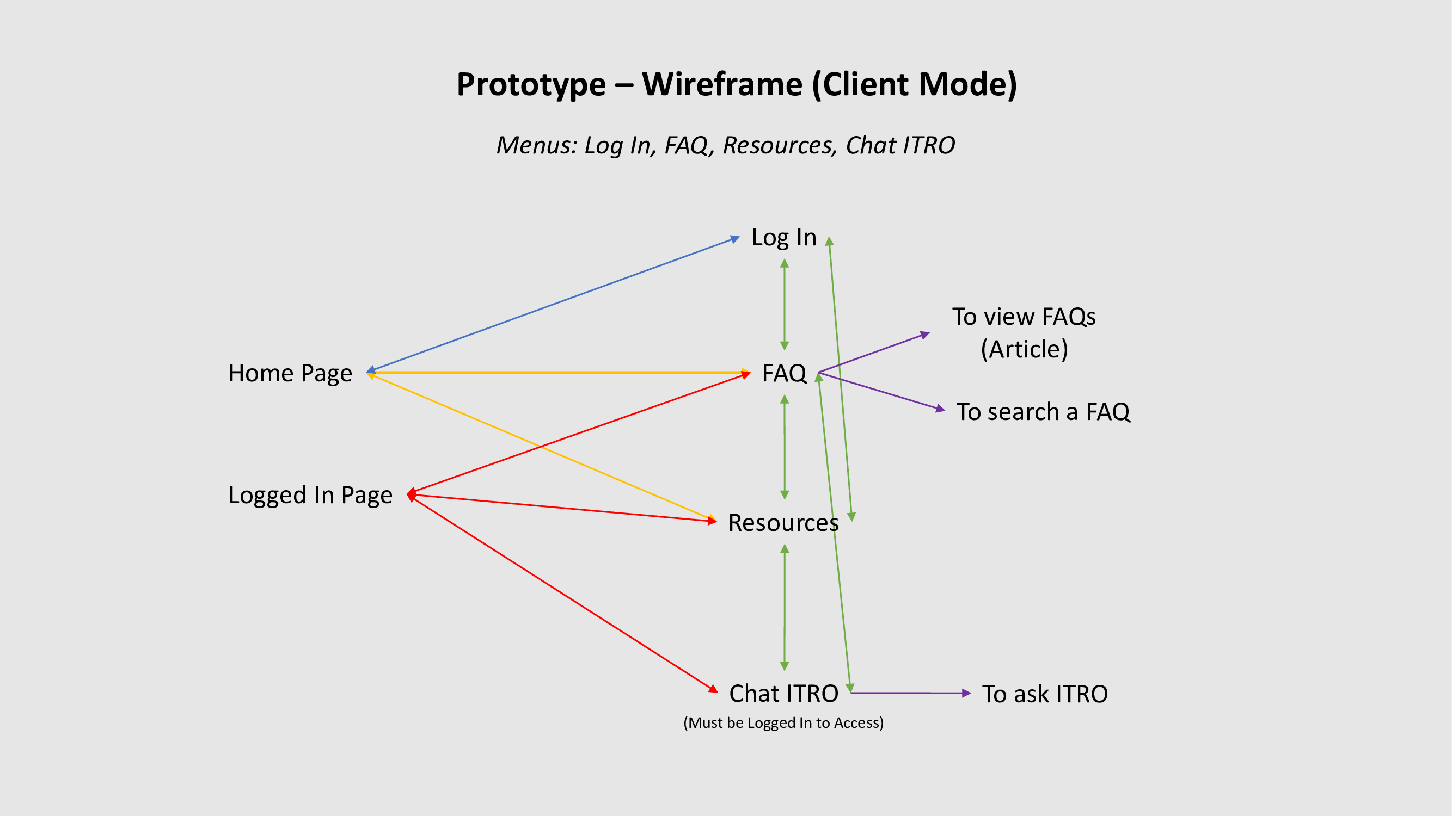

Figure Client Mode Wireframe

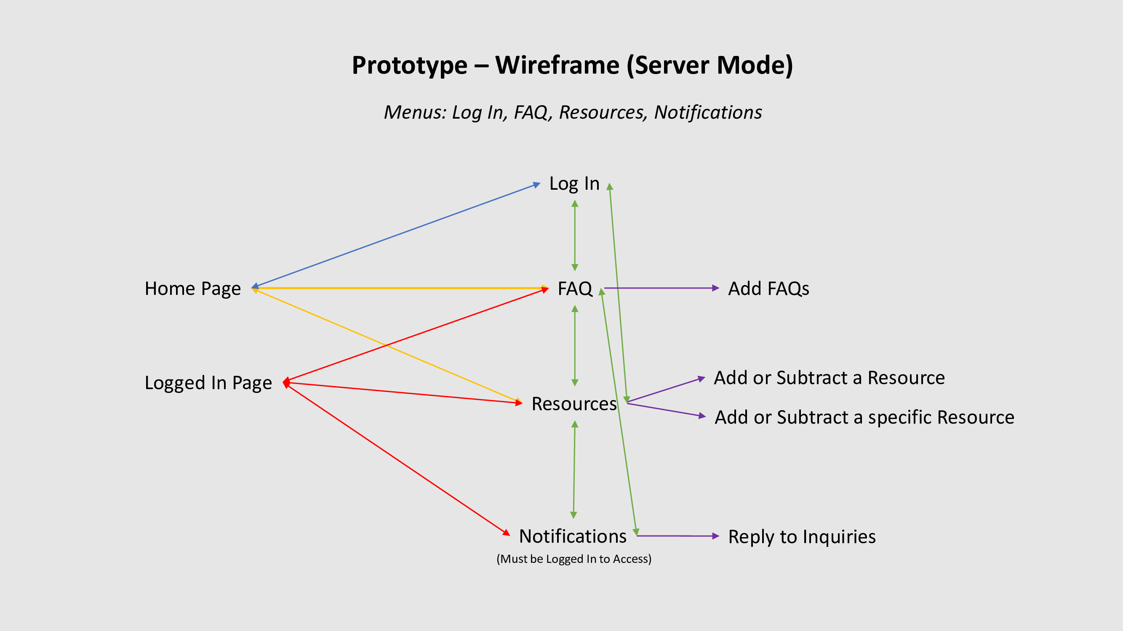

Figure Server Mode Wireframe

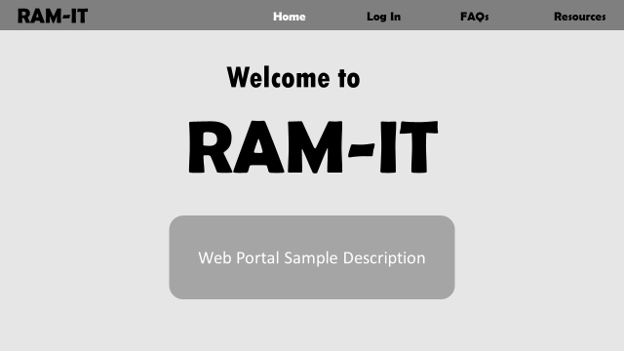

Figure Server & Client Mode - Home Page

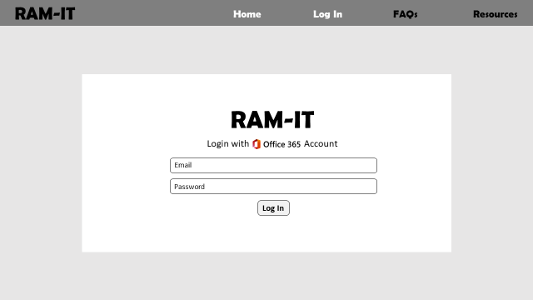

Figure Server & Client Mode - Login Page

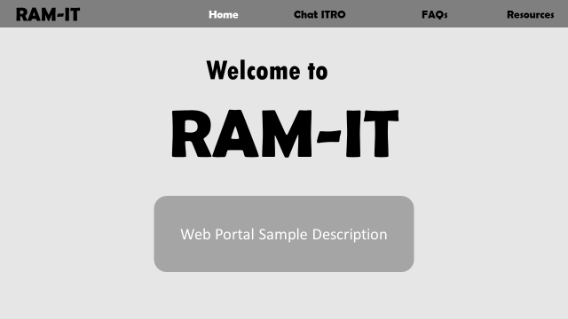

Figure Client Mode - Logged In Home Page

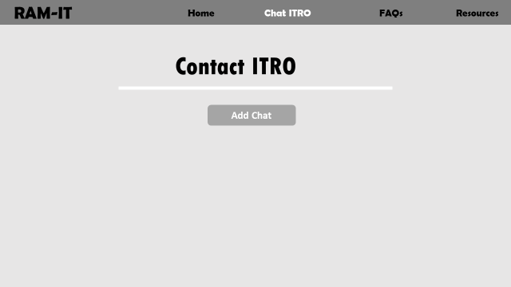

Figure Client Mode – Contact ITRO

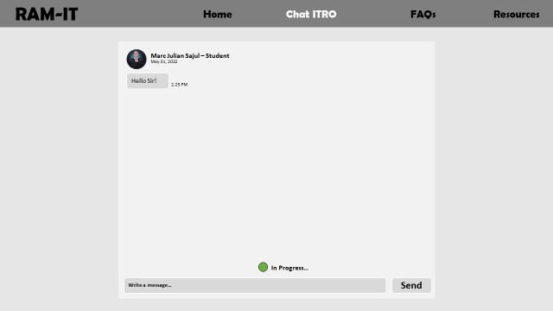

Figure Client Mode - Chat System

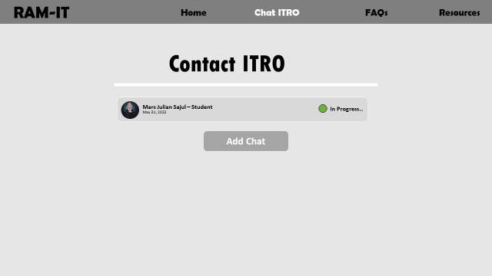

Figure Client Mode – Contact ITRO w/ Progress

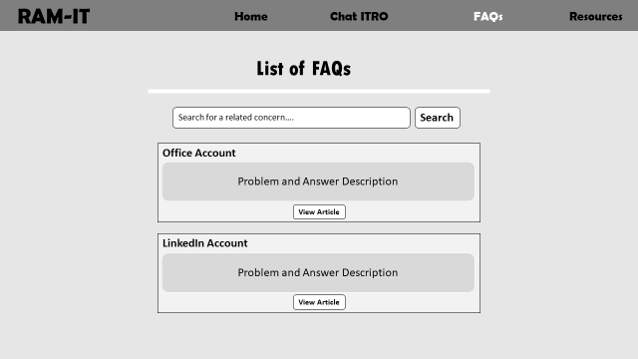

Figure Client Mode – List of FAQ Articles

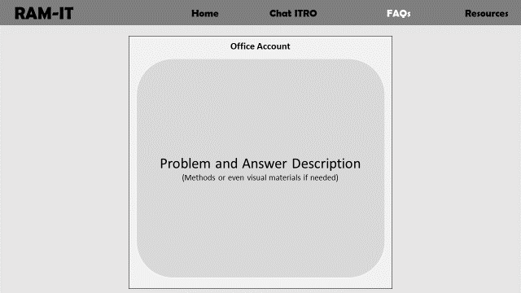

Figure Client Mode – FAQ Article

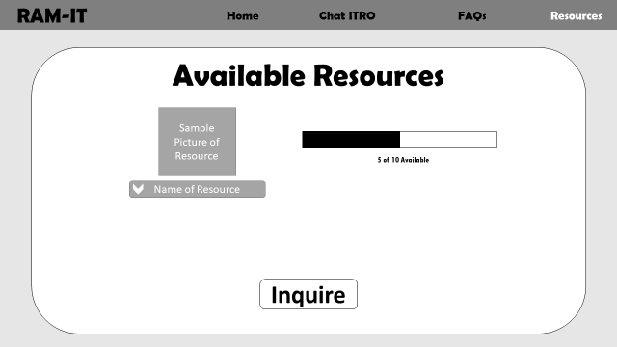

Figure Client Mode – Resources

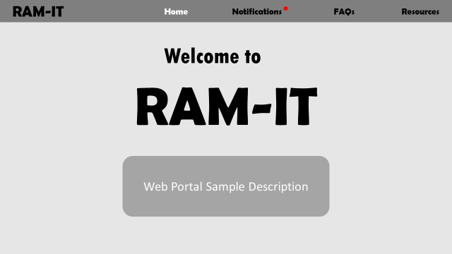

Figure Server Mode - Logged In Home Page

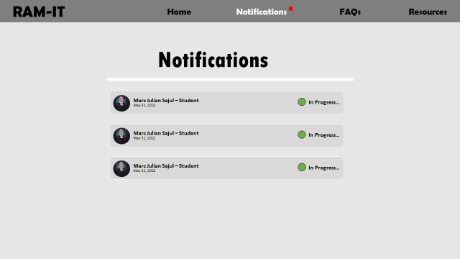

Figure Server Mode - Notifications

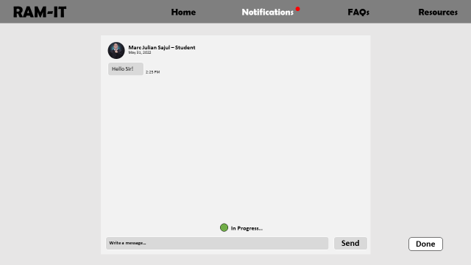

Figure Server Mode - Chat System

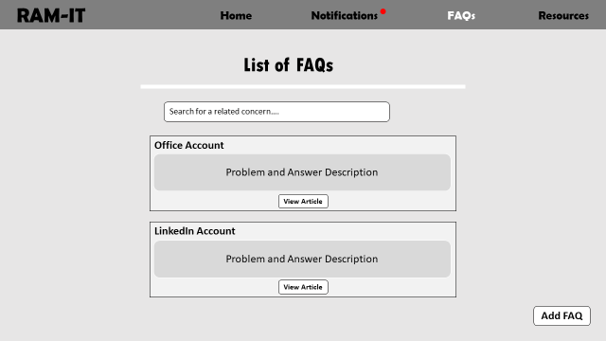

Figure Server Mode – List of FAQs Article

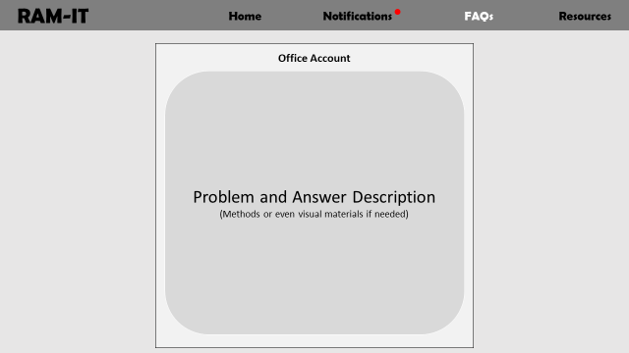

Figure Server Mode – FAQ Article

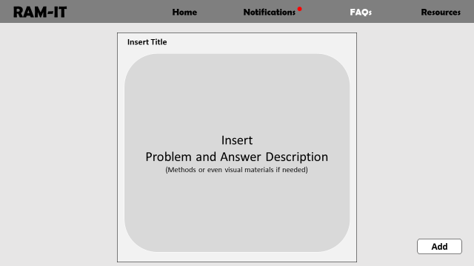

Figure Server Mode – Add FAQ

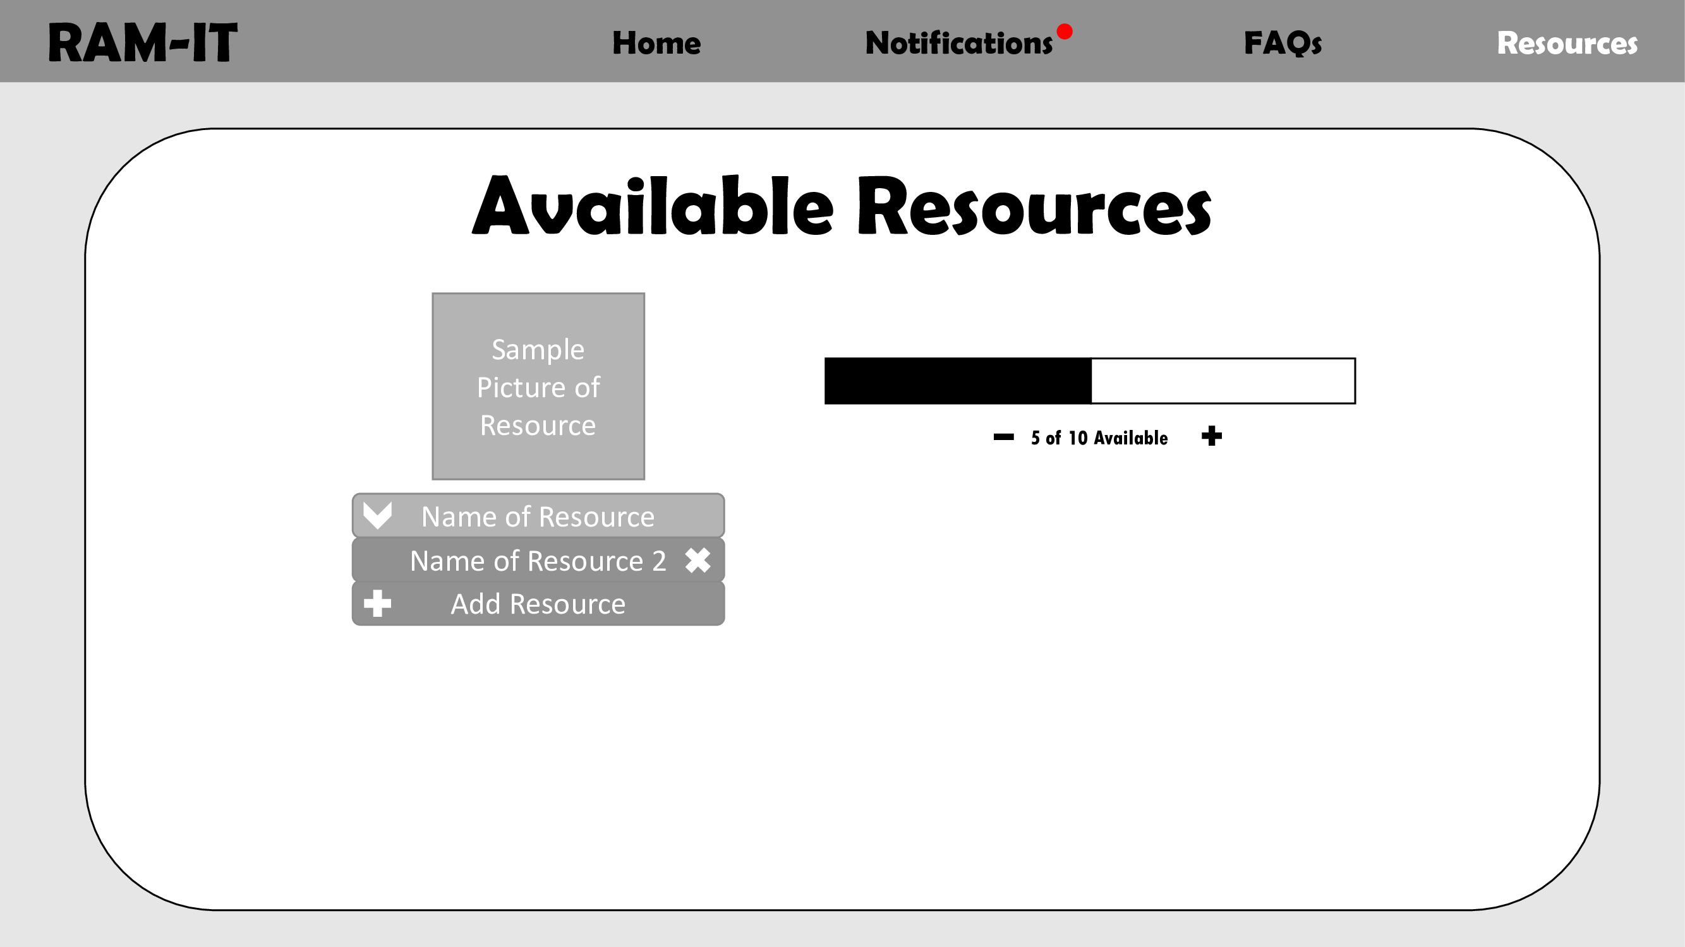

Figure Server Mode – Resources

### Product Roadmap

|  |  |  |  |
| --- | --- | --- | --- |
| **June 2022**  **Milestone 1**   * Prototype   June 22, 2022 | **September 2022**  **Milestone 2**   * Login   **Milestone 3**   * FAQs * FAQ Add/View post   **Milestone 4**   * FAQ Search Algorithm | **November 2022**  **Milestone 5**   * Chat System * Inquiry Status   **Milestone 6**   * Notification System | **January 2023**  **Milestone 7**   * Resources   **Milestone 8**   * Tested Account * Tested Security * Fixed Bugs |

|  |
| --- |
| **March 2023**  **Milestone 9**   * Tested Web portal   **Milestone 10**   * Tested and Debugged Web portal   **Milestone 11**   * Release |

Table Product Roadmap

### Release Plan

|  |
| --- |
| **June 2022**  **Milestone 1**   * Prototype   June 22, 2022 |

**Release 1**

* User can visualize the web portal
* User will know how the web portal work
* User will know the flow of the web portal
* User can visualize the features of the web portal

|  |
| --- |
| **September 2022**  **Milestone 2**   * Login   **Milestone 3**   * FAQs * FAQ Add/View post   **Milestone 4**   * FAQ Search Algorithm |

**Release 2**

* User can test the web portal
* User can login
* User can see their identity
* User can view the FAQ page
* User can post in FAQ page
* User can view posts in the FAQ page
* User can view the list of FAQs
* User can view the methods of listed concerns
* User can view and read a specific concern in a form of an article
* User can search a specific or related concern

|  |
| --- |
| **November 2022**  **Milestone 5**   * Chat System * Inquiry Status   **Milestone 6**   * Notification System |

**Release 3**

* User can experience chat system
* User can view if the concern is done or in progress
* User can stop a chat
* User can be notified if a student will post a concern or an inquiry

|  |
| --- |
| **January 2023**  **Milestone 7**   * Resources   **Milestone 8**   * Tested Account * Tested Security * Fixed Bugs |

**Release 4**

* User can add and subtract a resource
* User can add and subtract a specific resource
* User can view the available resources
* School account will be tested
* School account and web portal’s security will be tested
* Fix bugs (Account and Security)

|  |
| --- |
| **March 2023**  **Milestone 9**   * Tested Web portal   **Milestone 10**   * Tested and Debugged Web portal   **Milestone 11**   * Release |

**Release 5**

* Tested the web portal’s features
* Fix bugs in the web portal
* Web portal will be released for the school

Table Release Plan

# Conclusion

What the proponents finished so far, finished the initial prototype along with the wireframe that quickly shows how basically the web portal works. The team also compiled and finished all the product backlog, the proposed ideas that is sorted by its sprints and its priority. The product roadmap is finished and so as the product release plan. This will be helpful for the team in the future to set features deadlines and it will help the team to see an unobstructed vision for the goal of that schedule, it will be difficult to stray to the path that was paved by the roadmap and release plan.

In the future the sprint will start, and the order of the sprints will dictate which features are first and a priority of the group to achieve on that specific date of the schedule. The development will be sanctioned by APC, and it is supervised by the client and the project adviser.

# References

|  |  |
| --- | --- |
| [1] | A. Blackwelder, "Using a School News Program to Promote Positivity During the Pandemic," edutopia, 20 November 2020. [Online]. Available: https://www.edutopia.org/article/using-school-news-program-promote-positivity-during-pandemic. [Accessed 30 April 2022]. |
| [2] | National Learning Center on Safe Supportive Learning Environments, "At what stage of implementing Integrated Student Supports (ISS) is your school?," National Learning Center on Safe Supportive Learning Environments, [Online]. Available: https://safesupportivelearning.ed.gov/voices-field/what-stage-implementing-integrated-student-supports-iss-your-school.. [Accessed 30 April 2022]. |
| [3] | L. BRIONES, "GUIDELINES ON THE ENGAGEMENT OF SERVICES OF LEARNING SUPPORT AIDES TO REINFORCE THE IMPLEMENTATION OF THE BASIC EDUCATION LEARNING CONTINUITY PLAN IN TIME OF COVID-19 PANDEMIC," 15 October 2020. [Online]. Available: https://www.deped.gov.ph/wp-content/uploads/2020/10/DO_s2020_032-1-1.pdf. [Accessed 22 June 2022]. |
| [4] | R. Ranjan, "Benefits of having students portal," EASY MANAGEMENT NOTES, 30 August 2020. [Online]. Available: https://www.easymanagementnotes.com/benefits-of-having-students-portal/. [Accessed 30 April 2022]. |
| [5] | B. M. Zinck, "Why every college and University needs a modern student portal," Ingeniux, [Online]. Available: https://www.ingeniux.com/blog/why-every-college-and-university-needs-a-modern-student-portal. [Accessed 30 April 2022]. |
| [6] | H. Azham, A. Sadiq, B. M. Mustafa and M. Fatma, "Assessing and Testing the Usability of Student Portal," AIP Conference Proceedings, 27 September 2018. [Online]. Available: https://aip.scitation.org/doi/pdf/10.1063/1.5055453#:~:text=A%20student%20portal%20is%20an,schedules%20and%20department%20contact%20numbers. [Accessed 30 April 2022]. |
| [7] | Modo Labs, "How Ivy Tech Community College Used Mobile to Keep Students on Track to Graduate," Modo Labs, [Online]. Available: https://www.modolabs.com/customer-stories/customer-stories-ivy-tech/. [Accessed 30 April 2022]. |
| [8] | California Department of Education, "Distance Learning," California Department of Education, 21 June 2022. [Online]. Available: https://www.cde.ca.gov/ci/cr/dl/. [Accessed 22 June 2022]. |
| [9] | L. Renard, "20 ways teachers can give differentiated instructions to students," bookwidgets, 19 September 2019. [Online]. Available: https://www.bookwidgets.com/blog/2019/09/20-ways-teachers-can-give-differentiated-instructions-to-students. [Accessed 22 June 2022]. |
| [10] | J. Bittner, "Does Your School Website Need an FAQ Page?," schoolwebmasters, n.d. [Online]. Available: https://www.schoolwebmasters.com/Blog_Articles?entityid=643361. [Accessed 22 June 2022]. |
| [11] | J. Laukkonen, "What Is a Notification System?," 26 May 2022. [Online]. Available: https://www.easytechjunkie.com/what-is-a-notification-system.htm. |
| [12] | EXPLAINER, "Web Push Notifications Explained," [Online]. Available: https://www.airship.com/resources/explainer/web-push-notifications-explained/#:~:text=Web%20push%20notifications%20are%20notifications,desktop%20web%20and%20mobile%20web.. |
| [13] | C. Lowe, "Web Push Notifications Mastery Guide," Insider, 2 December 2019. [Online]. Available: https://useinsider.com/what-is-web-push-notification/. |
| [14] | "What is an SMS Notification? - Guide," 16 October 2020. [Online]. Available: https://sendpulse.com/support/glossary/sms-notification. |
| [15] | GeeksforGeeks, "searching-algorithms," 18 June 2022. [Online]. Available: https://www.geeksforgeeks.org/linear-search/. [Accessed 27 June 2022]. |
| [16] | GeeksforGeeks , "linear-search," 23 June 2022. [Online]. Available: https://www.geeksforgeeks.org/linear-search/. [Accessed 27 June 2022]. |
| [17] | GeekforGeeks, "binary-search," 17 June 2022. [Online]. Available: https://www.geeksforgeeks.org/binary-search/. [Accessed 27 June 2022]. |
| [18] | S. Peek and S. Angeles, "What Is Agile Scrum Methodology?," Business News Daily, 22 December 2021. [Online]. Available: https://www.businessnewsdaily.com/4987-what-is-agile-scrum-methodology.html. [Accessed 4 June 2022]. |

# Appendices

## Appendix A: Methodology

The proponents will be using the **Agile Scrum methodology**. This methodology combines the incremental approach of agile and the framework for effective collaborations among teams of scrum [18].

The Agile Scrum methodology is great for best production of a product proposal in the smallest possible amount of time. It’s flexible making it perfect for adapting quickly to changes.

**The roles in the Agile Scrum Methodology includes:**

The **Scrum Master** who will be responsible for facilitating the scrum development Process [18].

The **Product Owner** ensures the stakeholders are delivered value [18]. They handle the product expectation, records changes to the product written in a scrum backlog [18].

The **Scrum Team** is usually three to nine individuals who have the proper skills – such as design, analyzing, and coding – to carry out the actual work [18].

## Appendix B: Minutes of the Meetings

**Client (Mr. Jojo F. Castillo):**

**Minutes of the Meeting – 05/05/2022**

Figure Minutes of the Meeting – 05/05/2022

Opening:

Online meeting of the Optimum Five group with Sir Jojo Castillo (Client), called to order at 1:00 PM – 1:30 PM on May 4, 2022, in Microsoft Teams.

Present

Jayson Aloya

Jan Gabriel Prion

John Christopher Langcauon

Absent

Marc Julian Sajul

Marc Zamora

Approval of Documentation

Approval of Documentation made by John Christopher Langcauon and seconded by Jayson Aloya

Agenda

* Interview with Sir Jojo Castillo (Client)
  + What are the scope of ITRO?
  + What are the problems that ITRO is currently facing?
  + What are the networking accounts ITRO handles?
  + Have you heard of the APC Freedom Wall?
  + What are the good things that you’ve observed from the Freedom Wall?
  + Where do you get your updates and notifications about Asia Pacific College?
  + Thoughts on Microsoft Teams having the feature where you can toggle in different applications such as Trello, Yammer, etc. inside the application?
  + Do you think gamifying content can help student’s intake information better or is the traditional way much better?
  + How often do you check the RAMpage in the Asia Pacific College website?

Adjournment:

Meeting was adjourned in 12:43 PM by Jayson Aloya, as well as the next meeting will TBD, while remaining to be online with the use of Microsoft Teams.

**Minutes of the Meeting – 05/11/2022**

Opening:

Online meeting of the Optimum Five group with Sir Jojo Castillo (Client), called to order at 9:00 AM – 9:30 AM on May 11, 2022, in Microsoft Teams.

Present

Jayson Aloya

John Christopher Langcauon

Marc Zamora

Marc Julian Sajul

Absent

Jan Gabriel Prion

Approval of Documentation

Approval of Documentation made by John Christopher Langcauon and seconded by Jayson Aloya

Agenda

* Client Suggestions
  + Electric Bulletin Boards
* Meeting w/ Adviser
* Website or WebApp
* Three Focal Points
  + Notification & Information
  + Interaction & Engagement
  + HyFlex

Adjournment:

Meeting was adjourned in 9:28 AM by Jayson Aloya, as well as the next meeting will TBD, while remaining to be online with the use of Microsoft Teams.

**Minutes of the Meeting – 05/25/2022**

Figure Minutes of the Meeting – 05/25/2022

Opening:

Online meeting of the Optimum Five group with Sir Jojo Castillo (Client), called to order at 9:20 AM – 10:00 AM on May 25, 2022, in Microsoft Teams.

Present

Jayson Aloya

Marc Zamora

Absent

Jan Gabriel Prion

Marc Julian Sajul

John Christopher Langcauon

Approval of Documentation

Approval of Documentation made by John Christopher Langcauon and seconded by Jayson Aloya

Agenda

* Discussion about Project Name
  + FoRAM: APC’s Informative WebApp
* Discussion about WebApp’s key difference from APC Official Website
* Discussion and revisions about Statement of the Problem
* Discussion about Scopes and Limitations
* Discussion about the different users of the project
  + Student
  + Teachers
  + Schools & Offices
  + RAMpage
  + Moderator
  + Personnel

Adjournment:

Meeting was adjourned in 10:00 AM by Jayson Aloya, as well as the next meeting will TBD, while remaining to be online with the use of Microsoft Teams.

**Minutes of the Meeting - 6/1/2022**

Figure Minutes of the Meeting – 06/01/2022

Opening:

Online meeting of the Optimum Five group with Sir Jojo Castillo (Client), called to order at 9:00 AM – 9:30 AM on June 1, 2022, in Microsoft Teams.

Present

Jayson Aloya

John Christopher Langcauon

Marc Julian Sajul

Jan Gabriel Prion

Absent

Marc Zamora

Approval of Documentation

Approval of Documentation made by John Christopher Langcauon and seconded by Jayson Aloya

Agenda

* Client’s comments and suggestions for project paper
  + Statement of the problem changes
* Showcase of prototype/wireframe
  + Can be used to create the product backlog
* Project Prototype showcase

Adjournment:

Meeting was adjourned in 9:40 AM by Jayson Aloya, as well as the next meeting will be held on June 1, 2022, online with the use of Microsoft Teams.

**Minutes of the Meeting - 6/3/2022**

Opening:

Online meeting of the Optimum Five group with Sir Jojo Castillo (Client), called to order at 10:00 AM – 11:00 AM on June 3, 2022, in Microsoft Teams.

Figure Minutes of the Meeting – 06/03/2022

Present

Jayson Aloya

John Christopher Langcauon

Marc Julian Sajul

Marc Zamora

Absent

Jan Gabriel Prion

Approval of Documentation

Approval of Documentation made by John Christopher Langcauon and seconded by Jayson Aloya

Agenda

* Project paper revisions and discussion with Sir Jojo Castillo (Client)
  + Statement of the Problem
  + SWOT Analysis
  + Objectives
  + Significance of the Study
  + Scopes and Limitations
  + Users Classes & Characteristics
* Product Backlog Showcase

Adjournment:

Meeting was adjourned in 10:34 AM by Jayson Aloya, as well as the next meeting will be held on June 8, 2022, online with the use of Microsoft Teams.

**Adviser (Ms. Jo Anne M. de la Cuesta):**

**Minutes of the Meeting - 5/10/2022**

Figure Minutes of the Meeting – 05/10/2022

Opening:

Online meeting of the Optimum Five group with Ms. Jo Anne de la Cuesta (Adviser), called to order at 9:30 AM – 10:00 AM on May 9, 2022, in Microsoft Teams.

Present

Jayson Aloya

John Christopher Langcauon

Marc Julian Sajul

Absent

Jan Gabriel Prion

Marc Zamora

Approval of Documentation

Approval of Documentation made by John Christopher Langcauon and seconded by Jayson Aloya

Agenda:

* Discussion about Client Suggestions
* Questions for the Adviser
  + How should we approach those who will also have features in our website? (i.e., RAMpage, Finance Office, etc.)
  + Should we find consultants?

Adjournment:

Meeting was adjourned in 10:09 AM by Jayson Aloya, as well as the next meeting will be held on May 16 ,2022 online with the use of Microsoft Teams.

**Minutes of the Meeting - 5/17/2022**

Figure Minutes of the Meeting – 05/17/2022

Opening:

Online meeting of the Optimum Five group with Ms. Jo Anne de la Cuesta (Adviser), called to order at 9:30 AM – 10:00 AM on May 16, 2022, in Microsoft Teams.

Present

Jayson Aloya

John Christopher Langcauon

Marc Julian Sajul

Marc Zamora

Absent

Jan Gabriel Prion

Approval of Documentation

Approval of Documentation made by John Christopher Langcauon and seconded by Jayson Aloya

Agenda:

* Roles & Responsibilities of each member
  + Chapter One (Introduction):
    - Aloya – Objectives
    - Langcauon – Significance of the Problem
    - Prion – Project Context
    - Sajul – Scope and Limitations
    - Zamora – Statement of the Problem
  + Chapter Two (RRL):
    - RRL Outline – Jayson
    - RRL Delegation – TBD
  + Chapter Three (Methodology):
    - Aloya – Analytics
    - Langcauon – Cloud
    - Prion – Social
    - Sajul – Mobile
    - Zamora – Security, Software Methodology
  + Chapter Four (Results & Discussion)
    - Aloya – Current System: Technical Background, Proposed Solution: Technical Background, Operational Feasibility
    - Langcauon – Current System: List of Processes
    - Prion – Economic Feasibility
    - Sajul – Technical Feasibility, Proposed Solution: Requirements Analysis
    - Zamora – Current System: SWOT Analysis, Schedule Feasibility
  + Chapter Five (Conclusion)
    - Prion – Conclusion
  + Executive Summary & Appendices
    - Aloya – Appendix 2: Schedule, Organizing Final Paper
    - Langcauon – Appendix 3: Project Meetings, Creating of PPT
    - Prion – Executive Summary
    - Sajul – Appendix 1: Project Vision
* Timetable for the progression of the group
  + May 19 – Deadline of Chapter 1
  + May 23 – Deadline of Chapter 2
  + May 26 – Deadline of Chapter 3
  + May 30 – Deadline of Chapter 4
  + June 1 – Deadline of Chapter 5 & Executive Summary
  + June 2- Deadline of Appendices
  + June 3 – Deadline of Prototype
  + June 4 – Deadline of Finals Paper
  + June 6 – Deadline of PPT
  + June 7 – Dry Run 1
  + June 8 – Dry Run 2
  + June 9 – Finals Presentation
* SOP Progression Report
  + Version 0 – Statement of the Problem
    - Asia Pacific College uses different platforms for spreading information, encouraging interaction, and promoting itself and its organizations, when it can be centralized into one platform.
  + Version 1- Statement of the Problem
    - Forum for Questions
    - Notifications and Updates
    - Student Wall
    - HyFlex Bulletin Board Banners

Adjournment:

Meeting was adjourned in 10:09 AM by Jayson Aloya, as well as the next meeting will be held on May 23 ,2022 online with the use of Microsoft Teams.

**Minutes of the Meeting – 05/24/2022**

Figure Minutes of the Meeting – 05/24/2022

Opening:

Online meeting of the Optimum Five group with Ms. Jo Anne de la Cuesta (Adviser), called to order at 9:00 AM – 10:00 AM on May 23, 2022, in Microsoft Teams.

Present

Jayson Aloya

John Christopher Langcauon

Marc Zamora

Marc Julian Sajul

Absent

Jan Gabriel Prion

Approval of Documentation

Approval of Documentation made by John Christopher Langcauon and seconded by Jayson Aloya

Agenda:

* Showcase of Project Name
  + FoRAM: APC’s Informative WebApp
* Discussion about APC Official Website’s functions and potential similar features
* APC Freedom Wall
  + Redacted, since it’s not a credible source of information since it is not being ran or approved by Asia Pacific College.
* Statement of the Problem
* Scope and Limitations
* Users

Adjournment:

Meeting was adjourned in 10:01 AM by Jayson Aloya, as well as the next meeting will be on May 30, 2022, while remaining to be online with the use of Microsoft Teams.

**Minutes of the Meeting – 05/31/2022**

Figure Minutes of the Meeting – 05/31/2022

Opening:

Online meeting of the Optimum Five group with Ms. Joanne de la Cuesta, called to order at 9:00 AM – 10:00 AM on May 30, 2022, in Microsoft Teams.

Present

Jayson Aloya

John Christopher Langcauon

Marc Zamora

Absent

Marc Julian Sajul

Jan Gabriel Prion

Approval of Documentation

Approval of Documentation made by John Christopher Langcauon and seconded by Jayson Aloya

Agenda:

* Questions from project team to adviser
  + Should we create a separate page in our web portal of RAMpage or just directories?
  + Does live forums sounds good?
  + Do you know of a free software we can make a working prototype on?
* Project Paper Revisions
  + Statement of the Problem
    - Statement 1 – Grammar fix
    - Statement 2 – Change low engagement to visibility or accessibility
  + Objectives
    - Don’t mention features
    - Use news & updates, instead of RAMpage
    - Remove the last part of main objective

Adjournment:

Meeting was adjourned in 10:07 AM by Jayson Aloya, as well as the next meeting will June 2, 2022, while remaining to be online with the use of Microsoft Teams.

**Minutes of the Meeting - 6/2/2022**

Figure Minutes of the Meeting – 06/02/2022

Opening:

Online meeting of the Optimum Five group with Sir Jojo Castillo (Client), called to order at 11:30 AM – 12:30 PM on June 2, 2022, in Microsoft Teams.

Present

Jayson Aloya

John Christopher Langcauon

Jan Gabriel Prion

Marc Zamora

Absent

Marc Julian Sajul

Approval of Documentation

Approval of Documentation made by John Christopher Langcauon and seconded by Jayson Aloya

Agenda

* Project Paper Revisions Follow-Up from Meeting w/ Client (Jojo Castillo)
  + Statement of the Problem
  + Scope and Limitations
    - Remove all “The scope of the project” phrases at the beginning of your scope statements.
    - Avoid using negative terms
  + RRL Outline
    - Rearrange based on client’s priorities in the SOP
  + RRL Review
  + Product Vision
    - Base it on the format given
  + User Classes & Characteristics
  + Product Backlog & Roadmap
    - In progress
  + Conclusion
    - Revision because of Project revisions.
  + Wireframe Showcase
* Prototype Showcase

Adjournment:

Meeting was adjourned in 12:43 PM by Jayson Aloya, as well as the next meeting will TBD, while remaining to be online with the use of Microsoft Teams.

**Instructor (Ms. Roselle Wednesday L. Gardon):**

**Minutes of the Meeting – 05/12/2022**

Figure Minutes of the Meeting – 05/12/2022

Opening:

Online meeting of the Optimum Five group with Sir Jojo Castillo (Client), called to order at 11:30 AM –12:00 PM on May 12, 2022, in Microsoft Teams.

Present

Jayson Aloya

John Christopher Langcauon

Marc Julian Sajul

Absent

Marc Zamora

Jan Gabriel Prion

Approval of Documentation

Approval of Documentation made by John Christopher Langcauon and seconded by Jayson Aloya

Agenda

* Discussion about interview w/ Sir Jojo Castillo (Client)
* Dicussion about meeting w/ Ms. Jo Anne de la Cuesta (Adviser)
* Question on whether to pursue WebApp or Website
* Discussion about three focal points of our project
  + Notification & Information
  + Interaction & Engagement
  + HyFlex

Adjournment:

Meeting was adjourned in 12:03 PM by Jayson Aloya, as well as the next meeting will TBD, while remaining to be online with the use of Microsoft Teams.

**Minutes of the Meeting – 05/19/2022**

Figure Minutes of the Meeting – 05/19/2022

Opening:

Online meeting of the Optimum Five group with Sir Jojo Castillo (Client), called to order at 1:20 PM – 2:00 PM on May 19, 2022, in Microsoft Teams.

Present

Jayson Aloya

John Christopher Langcauon

Marc Julian Sajul

Absent

Jan Gabriel Prion

Marc Zamora

Approval of Documentation

Approval of Documentation made by John Christopher Langcauon and seconded by Jayson Aloya

Agenda

* Discussion about Project Name
  + FoRAM
* SOP Progression Report
* Discussion about three modes of the project based on user type
  + Outsider
  + Student Mode
  + Department/Organization mode
* Discussion about four focal points of the project
  + Information
  + News
  + Interaction & Engagement
  + HyFlex
* Discussion about questions that were asked to the client
* Breakdown of Chapter I (Introduction): Objectives
* Breakdown of Chapter II (RRL): Outline

Adjournment:

Meeting was adjourned in 2:07 PM by Jayson Aloya, as well as the next meeting will TBD, while remaining to be online with the use of Microsoft Teams.

**Minutes of the Meeting – 5/30/2022**

Figure Minutes of the Meeting – 05/30/2022

Opening:

Online meeting of the Optimum Five group with Ms. Roselle Wednesday Gardon (Instructor), called to order at 2:00 PM – 2:32 PM on May 30, 2022, in Microsoft Teams.

Present

Marc Zamora

Jayson Aloya

John Christopher Langcauon

Marc Julian Sajul

Absent

Jan Gabriel Prion

Approval of Documentation

Approval of Documentation made by John Christopher Langcauon and seconded by Jayson Aloya

Agenda

* Showcase and Feedback discussion for Project Context, Statement of the Problem, Objectives, and Review of Related Literature and Systems w/ Ms. Roselle Wednesday Gardon

Adjournment:

Meeting was adjourned in 2:32 PM by Jayson Aloya, as well as the next meeting will be TBD, and will still be held online with the use of Microsoft Teams.

**Members:**

**

Figure Minutes of the Meeting – 04/14/2022

Opening:

Online meeting of the Optimum Five group called to order at 10:03 PM – 10:45 PM on April 14, 2022, in Microsoft Teams.

Present

Marc Zamora

Jayson Aloya

John Christopher Langcauon

Marc Julian Sajul

Jan Gabriel Prion

General Meeting

All of the documents and PowerPoints that are presented are made by Jayson Aloya

Agenda:

* Project Description
  + Working in progress
* Roles
  + Jayson Aloya
    - Group Leader / Representative
    - External Communication
  + Marc Julian Sajul
    - Group Leader Assistant
    - UI/UX Leader and Designer
  + John Christopher Langcauon
    - Documentation
  + John Gabriel Prion
    - Proofreading and Compiler
* Distribution Responsibilities
* Timetable
* Project Client
  + ITRO
* Project Adviser
  + Mr. Jose Eugenio L. Quesada (pending)
* Project Consultant
  + Ms. Jo Anne M. de la Cuesta (pending)
* Project Name
  + Working in progress

Adjournment:

Meeting was adjourned in 10:45 PM by Jayson Aloya, online with the use of Microsoft Teams.

**

Figure Minutes of the Meeting – 05/14/2022

Opening:

Online meeting of the Optimum Five group called to order at 10:39 PM – 11:00 PM on May 14, 2022, in Microsoft Teams.

Present

Marc Zamora

Jayson Aloya

John Christopher Langcauon

Marc Julian Sajul

Jan Gabriel Prion

Giving out roles and responsibility

All of the documents and PowerPoints that are presented are made by Jayson Aloya

Agenda:

* Giving out roles and responsibility
  + Giving out roles to members in chapter 1
    - J.G Prion (Project Context)
    - Marc E. Zamora (SOP)
    - Jayson Aloya (Objectives)
    - J.C Langcuaon (Significance of the project)
    - Marc Julian Sajul (Scope and limitations)
  + Giving out roles to members in chapter 3
    - J.G Prion (Social)
    - Marc E. Zamora (Security, Research what software Methodology can be used for the project)
    - Jayson Aloya (Analytics)
    - J.C Langcuaon (Significance of the project)
    - Marc Julian Sajul (Mobile)
  + Giving out roles to members in chapter 4
    - J.G Prion (Economic feasibility, Current system: technical background)
    - Marc E. Zamora (Schedule Feasibility, Current System: SWOT Analysis)
    - Jayson Aloya (Current System: Technical Background, Proposed Solution: Technical Background, Operational Feasibility, Proposed Solution: Mock-Up)
    - J.C Langcuaon (Current System: List of Processes)
    - Marc Julian Sajul (Technical Feasibility, Proposed Solution: Requirements Analysis, Proposed Solution: Prototype)
  + Giving out roles to members in chapter 5
    - J.G Prion (Conclusion)
  + Giving out roles to members in Executive Summary & Appendices
    - J.G Prion (Executive Summary)
    - Jayson Aloya (Appendix 2: Schedule)
    - J.C Langcuaon (Appendix 3: Project Meetings)
    - Marc Julian Sajul (Appendix 1: Project Vision)

Adjournment:

Meeting was adjourned in 11:00 PM by Jayson Aloya, as well as the next meeting will be held on May 14, 2022 (10:00-11:00 PM) online with the use of Microsoft Teams.

**

Figure Minutes of the Meeting – 05/16/2022

Opening:

Online meeting of the Optimum Five group called to order at 10:52 PM – 12:44 PM on May 16, 2022, in Microsoft Teams.

Present

Marc Zamora

Jayson Aloya

John Christopher Langcauon

Marc Julian Sajul

Jan Gabriel Prion

Progression

All of the documents and PowerPoints that are presented are made by Jayson Aloya

Agenda:

* Roles & Responsibilities
  + Updates of the timetable
* SOP template discussion
* Discussion of the grades that was given by the panelist to the group
  + Doc Manny Calimlim
    - Individual Grades
    - Comments
    - Group grade
  + Ms. Rhea Valbuena
    - Individual Grades
    - Comments
    - Group grade
* Discussion of the grades that was given by the adviser to the group
  + Ms. Jo Anne Cuesta
    - Individual Grades
    - Comments
    - Group grade
* Tour of the files tab of MS Teams
  + Where videos are located
  + Where files located

Adjournment:

Meeting was adjourned in 12:44 PM by Jayson Aloya, as well as the next meeting will be held on May 17, 2022 (10:00-11:00 PM) online with the use of Microsoft Teams.

**

Figure Minutes of the Meeting – 05/17/2022

Opening:

Online meeting of the Optimum Five group called to order at 10:41 PM – 1:43 AM on May 17, 2022, in Microsoft Teams.

Present

Marc Zamora

Jayson Aloya

John Christopher Langcauon

Marc Julian Sajul

Late

Jan Gabriel Prion

SOP Progression

All of the documents and PowerPoints that are presented are made by Jayson Aloya

Agenda:

* SOP Progression
  + Updates of the SOP
    - Version 1 (Jayson Aloya)
    - Version 1 (JC Langcauon)
    - Version 1 (Marc Julian Sajul)
    - Version 1 (Marc E. Zamora)
  + Q&A for each SOP
    - Version 1 (Jayson Aloya)
    - Version 1 (JC Langcauon)
    - Version 1 (Marc Julian Sajul)
    - Version 1 (Marc E. Zamora)
  + Looking for a commonality in each SOP to create a new SOP

Adjournment:

Meeting was adjourned in 1:43 AM by Jayson Aloya, as well as the next meeting will be held on May 18, 2022 (10:00-11:00 PM) online with the use of Microsoft Teams.

**

Figure Minutes of the Meeting – 05/18/2022

Opening:

Online meeting of the Optimum Five group called to order at 10:30 PM – 11:31 PM on May 18, 2022, in Microsoft Teams.

Present

Marc Zamora

Jayson Aloya

John Christopher Langcauon

Marc Julian Sajul

Absent

Jan Gabriel Prion

SOP Progression

All of the documents and PowerPoints that are presented are made by Jayson Aloya

Agenda:

* Title changes
  + Discussion about changes
* Ver 0 of SOP
  + Discussion
* Ver 1 of SOP
  + Discussion
* The modes of the site
  + Discussion
  + Clarifications
* The four focal points
  + Discussion
  + Agreement
* Sir Jojo's message to the group
  + Discussion
* The questions of the group to Sir Jojo
  + Discussion
  + Agreement
* Objectives
  + Discussion
* Chapter 2 outline
  + Discussion

Adjournment:

Meeting was adjourned in 11:31 PM by Jayson Aloya, as well as the next meeting will be held on May 19, 2022 (10:00-11:00 PM) online with the use of Microsoft Teams.

**

Figure Minutes of the Meeting – 05/19/2022

Opening:

Online meeting of the Optimum Five group called to order at 10:11 PM – 11:36 PM on May 19, 2022, in Microsoft Teams.

Present

Marc Zamora

Jayson Aloya

John Christopher Langcauon

Marc Julian Sajul

Absent

Jan Gabriel Prion

SOP Progression

All of the documents and PowerPoints that are presented are made by Jayson Aloya

Agenda:

* website vs webapp
  + Discussion
  + Vote for website or webapp (webapp wins)
  + Discussion about webapp
* Title changes
  + Discussion about changes
* Final paper template
  + Discussion
* Update of responsibilities
  + Discussion
* Viewpoints of users
  + Discussion
* The four focal points
  + Discussion
* SOP
  + Discussion
* Objectives
  + Discussion
* Chapter 2 outline
  + Discussion

Adjournment:

Meeting was adjourned in 11:36 PM by Jayson Aloya, as well as the next meeting will be held on May 21, 2022 (10:00-11:00 PM) online with the use of Microsoft Teams.

**

Figure Minutes of the Meeting – 05/21/2022

Opening:

Online meeting of the Optimum Five group called to order at 11:16 PM – 12:45 AM on May 21, 2022, in Microsoft Teams.

Present

Marc Zamora

Jayson Aloya

John Christopher Langcauon

Marc Julian Sajul

Absent

Jan Gabriel Prion

SOP Progression

All of the documents and PowerPoints that are presented are made by Jayson Aloya

Agenda:

* Title changes
  + Discussion about changes
* SOP Syntax
  + Discussion
* Presentation of SOP of Marc E. Zamora
  + Presentation
  + Q&A

Adjournment:

Meeting was adjourned in 12:45 AM by Jayson Aloya, as well as the next meeting will be held on May 28, 2022 (10:00-11:00 PM) online with the use of Microsoft Teams.

## Appendix C: Roles & Responsibilities

|  |  |  |  |  |
| --- | --- | --- | --- | --- |
| **Aloya, Jayson** | **Langcauon, John Christopher** | **Prion, Jan Gabriel** | **Sajul, Marc Julian** | **Zamora, Marc** |
| Product Owner | Documentations | Proofreader | UI & UX Leader | Scrum Master |
| Group Leader |  |  |  |  |
| External Communications |  |  |  |  |

Table Roles & Responsibilities